1. **Is data available for all days and time periods?**

* Above is the availability chart.

* High number of Tuesday and Wednesday data is available.

1. **Which is the busiest time/date/day of the week?**

* Busiest time is Morning and afternoon, followed by Evenings.

1. **The top 5 popular/ busiest stations: Stations where bikes are continuously removed and docked (Highly changing bike and dock available numbers)**

* Able to understand that stations around the university is the most popular- especially one next to Academic Building, Rec centre, C4C, Norlin, Rec centre and bus stand.

1. **Do the busiest/ popular stations have high capacity?**

* Half of the popular stations have high capacity. Or this could be vice-versa.

1. **Why is Timber Ridge popular?**

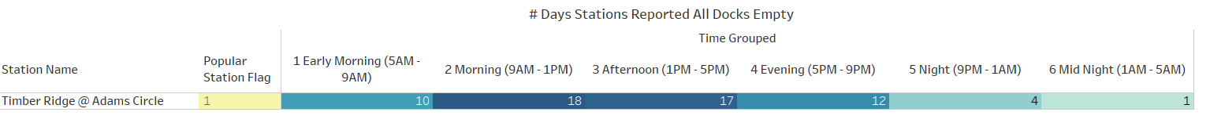



* Timber Ridge station reported full of bikes in the non-class times and reported empty during class times. This means that the **station could be near college students’ residential area.**

1. **Norlin station is not busy after evenings, because it have all docks empty after evenings?**

* Yes, it is common that all docks are empty in the evenings, but this is a common trend among all popular stations.
* However, Norlin is exceptionally reported All Bikes Available in the mornings a greater number of times than any other- **meaning people just use this station in the mornings more and do not use in the evenings**.

1. **Distribution of wait times across various stations- divided by factors:**

* Popular vs unpopular stations

* + Popular station have an average wait time of 91 mins however, it is only around 30mins in the busy times of the day.
* Across days for popular stations:

* + The wait times are lower in the weekdays than weekends in the popular stations:
    - For example, the wait time is only 12.9 mins Friday Morning.
    - Exceptions: Friday night has lesser wait times than other nights- Partying?

* + C4C is has the lowest waiting time- hence the populist station.
* Variance across stations, time and days?

* + Variance is low during **regular class days.**
  + Variance is low between **morning to evening**.
  + Variance is low in the **C4C station**.